Cyngor Bwrdeistref Sirol Wrecsam / Wrexham County Borough Council  Neuadd y Dref, Wrecsam. LL11 1AY  Guildhall, Wrexham. LL11 1AY  www.wrecsam.gov.uk www.wrexham.gov.uk  Cyfnewid Testun/Text Relay: 18001 |  | 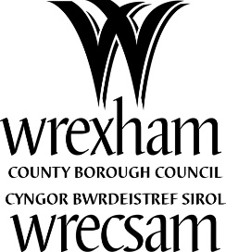
 | Eich Cyf/Your Ref
 | Ein Cyf/Our ref
 | Dyddiad/Date |  | 19/07/2023
 | Gofynner am/Ask for |  | School Meals Service
 | Rhif Cyswllt/Contact No |  | 01978 292000

Dear Parent/Carer
Changes to charges for morning play session in primary schools
Many primary schools in Wrexham offer a free breakfast before the start of school. Please be reassured that there will continue to be no charge for this meal.
However, to supplement the free breakfast session, many schools offer an additional play session and charge parents £1 per child (free to children who are eligible for free school meals).
While this rate has remained unchanged since the provision was introduced in 2018, due to increased staffing and administrative costs, and the fact that the council receives no external funding, this is no longer sustainable.
To make sure that schools are able to continue to provide these sessions, the fee per child for the play session will increase to £2 per child (50p for children who are eligible for free school meals) from September 1, 2023.
This increase does not affect the breakfast session immediately prior to the start of the school day, which remains free for all children.
We know this comes at a time when many residents are finding household costs a challenge. If you are struggling to meet your household costs, please visit Wrexham Council’s ‘help with the cost of living’ pages for advice on any other help you may be able to access.
Welsh Government also have a cost of living help web page, which provides information of sources of possible financial support.
If you would like your child to attend a breakfast session, please contact their school for the details.

Are you eligible for free school meals?
If you are on a low income, you may be entitled to free school meals as well as the School Essentials grant to help with buying school uniform and equipment. Please visit the story below to find out more:
Universal Primary Free School Meals scheme rolls out to Years 3 to 6 - Wrexham Council News
Yours sincerely

Steve O’Neill
Service Lead – Cleaning and Catering

