RILL Literacy Project and Miles Dyslexia Centre Open Day
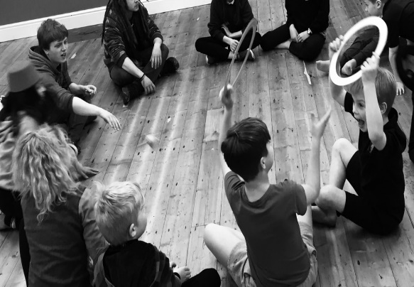

Saturday May 13
(Archimedes Centre, Cambrian House, Wrexham)
10am-12 noon = https://www.eventbrite.com/e/533812797447

For children in Year 2 to 5 and parents/guardians

Children’s Programme (with Circo Arts)
Circus skills session
Story session
Creative art activity

Parents’ Programme
Support your child with Literacy and Language.
Using Technology to support your child.

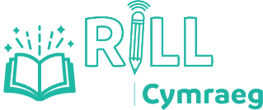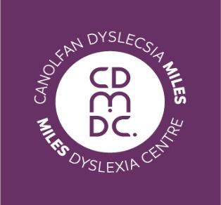

https://www.rillresearch.org/

