Parents’ Guide for Booking Appointments and How to attend your appointments via video call
Browse to https://ysgolbodhyfryd.schoolcloud.co.uk/
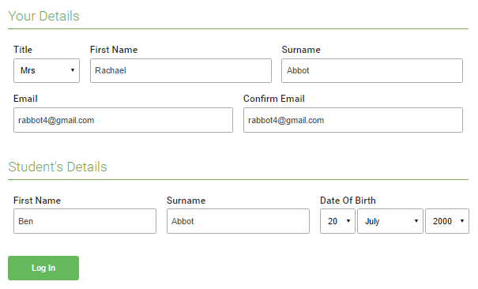 | Step 1: Login  Fill out the details on the page then click the Log In button.  A confirmation of your appointments will be sent to the email address you provide.
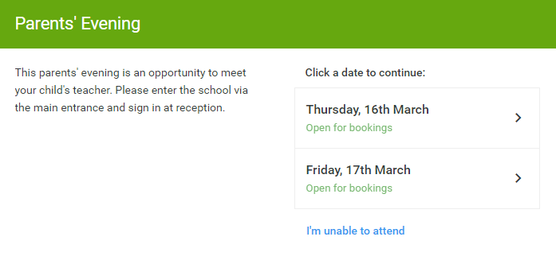 | Step 2: Select Parents' Evening  Click on the date you wish to book.  Unable to make all of the dates listed? Click I'm unable to attend.
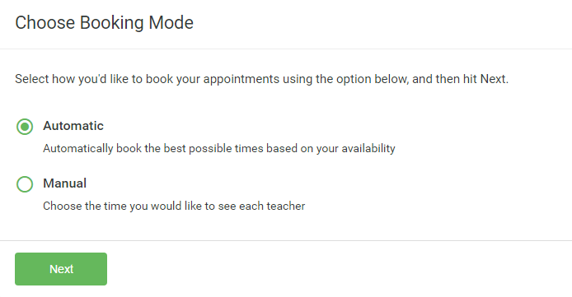 | Step 3: Select Booking Mode  Choose Automatic if you'd like the system to suggest the shortest possible appointment schedule based on the times you're available to attend. To pick the times to book with each teacher, choose Manual. Then press Next.  We recommend choosing the automatic booking mode when browsing on a mobile device.
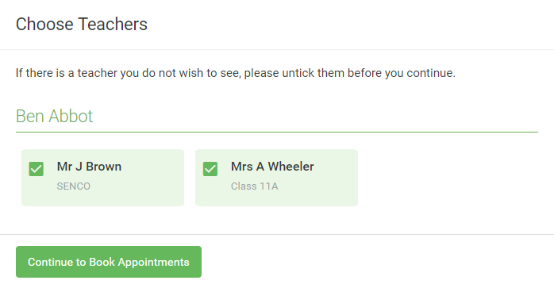 | Step 4: Choose Teachers  If you chose the automatic booking mode, drag the sliders at the top of the screen to indicate the earliest and latest you can attend.  Select the teachers you’d like to book appointments with. A green tick indicates they’re selected. To de-select, click on their name.
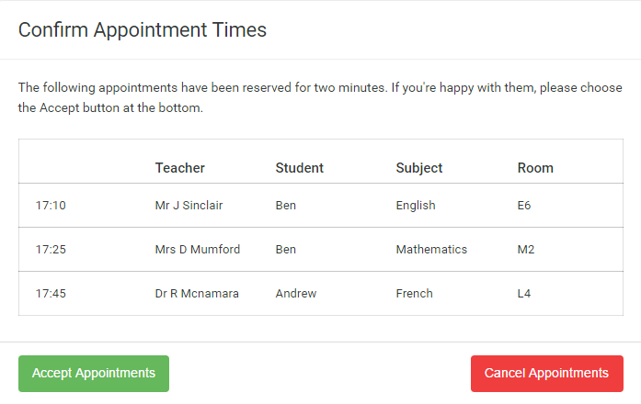 | Step 5a (Automatic): Book Appointments  If you chose the automatic booking mode, you'll see provisional appointments which are held for 2 minutes. To keep them, choose Accept at the bottom left.  If it wasn’t possible to book every selected teacher during the times you are able to attend, you can either adjust the teachers you wish to meet with and try again, or switch to manual booking mode (Step 5b).
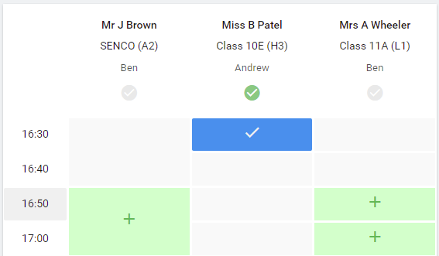 | Step 5b (Manual): Book Appointments  Click any of the green cells to make an appointment. Blue cells signify where you already have an appointment. Grey cells are unavailable.  To change an appointment, delete the original by hovering over the blue box and clicking Delete. Then choose an alternate time.  You can optionally leave a message for the teacher to say what you’d like to discuss, or raise anything beforehand.  Once you’re finished booking all appointments, at the top of the page in the alert box, press click here to finish the booking process.
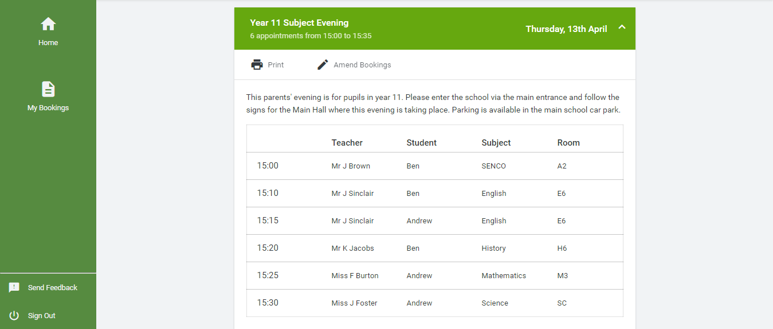 | Step 6: Finished  All your bookings now appear on the My Bookings page. An email confirmation has been sent and you can also print appointments by pressing Print. Click Subscribe to Calendar to add these and any future bookings to your calendar.  To change your appointments, click on Amend Bookings.

Additional information
In order to make video calls you need to have as a minimum:
- a device with a microphone and speaker/headphones
- a compatible up-to-date web browser:
- iPhone/iPad: Safari Note: there is a known issue joining video calls using iOS 14.2. Please upgrade any iOS 14.2 devices to iOS 14.3, or use an alternate device.
- Android: Chrome or Firefox
- Windows: Chrome, Firefox or Microsoft Edge (Chromium - download here)
- Mac: Safari, Chrome or Firefox
- Linux: Chrome or Firefox
We also recommend:
- Using your smartphone for video appointments. If you don't have a smartphone with a front-facing camera, use a laptop or computer with a webcam.
- Using a headset (or earphones with a microphone) to reduce echo.

How to attend your appointments via video call
An online guide can be viewed here https://support.parentseveningsystem.co.uk/article/801-video-parents-how-to-attend-appointments-over-video-call
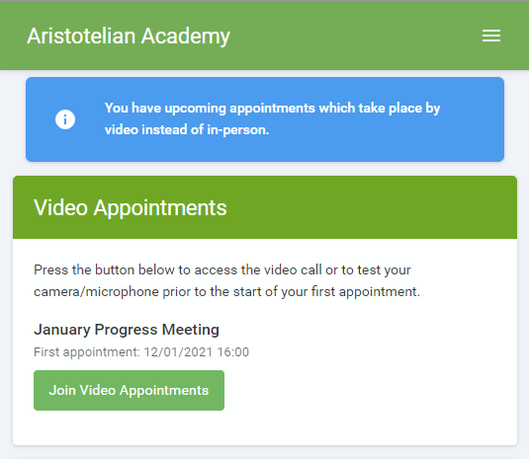
1. Log in and go to the Evening
On the day of the video appointments (or before, if you want to test your camera and microphone) login to Parents Evening at https://ysgolmorganllwyd.schoolcloud.co.uk/, or click the login link from the bottom of the email confirmation you will have received.
Once logged in you will see a notice that you have upcoming video appointments and under this the details of the event, along with a Join Video Appointments button.
Press the button to join your appointment on the day - or to test your camera/microphone at any time.
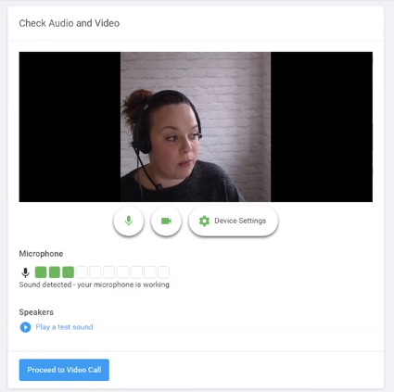
Check Audio and Video
When you click Join Video Appointments the Check Audio and Video screen will be displayed. You may at this point be asked if you wish to allow access to your camera/microphone, in which case please click yes.
From here you can turn on or off your microphone and camera, change which devices are being used for the call, and check your microphone and speakers. Once you are happy, click Proceed to Video Call.

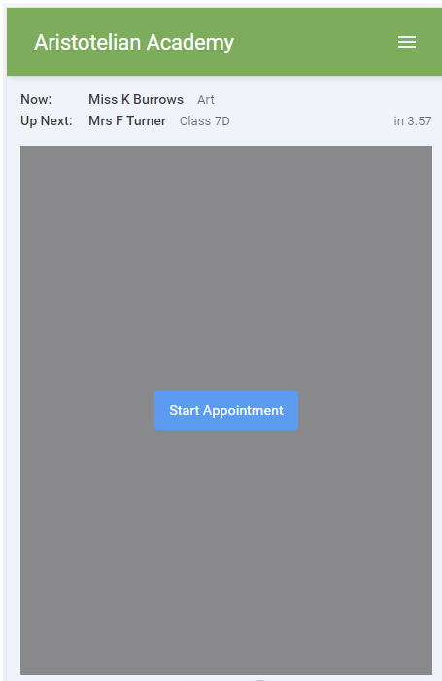
2. The Video Call
On this screen you can see the following, when in a call:
- At the top left the teacher name (and subject details) for the current and next appointment
- At the top right a countdown to the start of the appointment.
- At the bottom the controls for the microphone and camera.
When another person is available these also show a pick up button to start the call
and a hang up button to leave the call.

In the middle, when your appointment is due to start, the Start Appointment button.

3. Making a call
Click the Start Appointment button. You will see yourself in the bottom right corner of the screen (unless you have no camera, or have chosen to turn it off). If the teacher has not yet joined you will see a notice to that effect in the centre of the screen.
When a teacher joins a call you will see them in the main part of the screen - or hear them, if they have no camera (or have turned it off) - and can start your discussion with them.
You will also see the remaining time for the appointment counting down in a blue bar at the top of the screen, which will turn red when the last 10 seconds begin.
If anyone loses access to the system for some reason during the call, they can log in again and click Start Appointment on the video call screen. As long as the other person is still in the call this will let you continue with the appointment.
When the countdown in the blue bar stops the appointment time is over and the call will automatically end.
Note that if you or the teacher are late, or leave and rejoin the call, it does not reset the timer. The appointment will always end at the scheduled time.

4. Follow on calls
If you have a consecutive appointment scheduled the screen will display a Start Next Appointment button. When you are ready to proceed, click on it
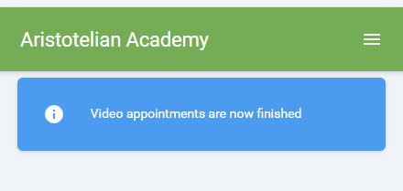
Note that if you delay starting a call it does not extend the duration for that appointment. The appointment will always end at the scheduled times.
If you do not have a consecutive appointment, but you have not completed your final scheduled appointment you will see a countdown telling you how long until the start of your next appointment.
Once your final appointment for the evening is complete you will see a message advising you of this.
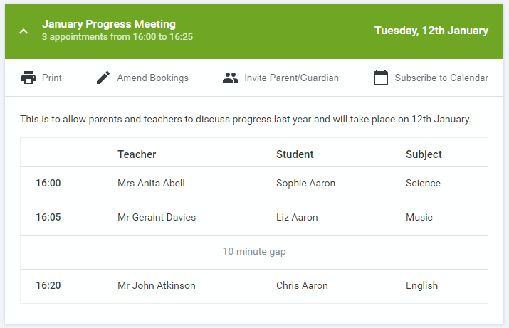
Inviting another parent/guardian to join your appointments
You can give one other parent/guardian access to join your video appointments in respect of each student linked to you that is involved in the conference. You can grant this access at the time of booking, or later if required.
1. Once you have made your bookings (or when you later log in and go to My Bookings) click on the Invite Parent/Guardian link at the top of the list of your bookings. If you have already sent an invitation this link will show as Manage Invites instead.
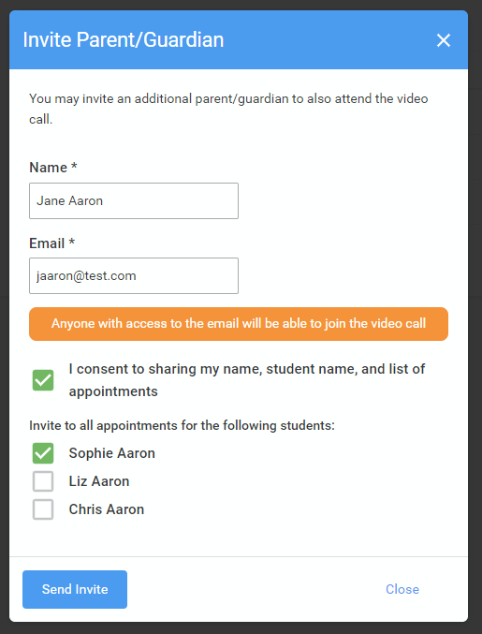
2. You will then be presented with a box asking for the details of the parent/guardian to be given access.
If there is more than one student linked to you and involved in the evening they will all be shown.
You must enter a Name, and an Email address, as well as tick the box to consent to that person being given access to the information used to make the appointments.
If there is more than one student linked to you, choose the student(s) in respect of whose appointments the access to this person will be granted. When you click the blue Send Invite button an email is sent to the address entered, giving them a link and details on how to join the call.
Here is an example of what the invite email looks like:
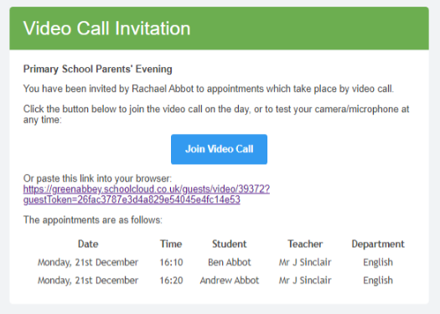
3. You will then see a Manage invites box that shows your sent invitation(s), allows you to add another invite if you have any more available (the person invited can be different for each student, if wished), and allows you to Resend invites or Remove them.

