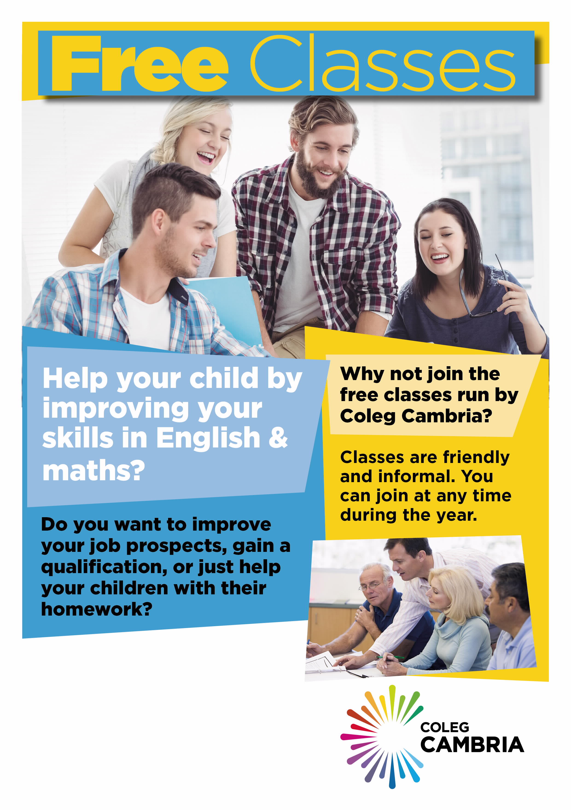

Free class starting online

September 2020!

If you are interested, please contact Heather Williams on **07925145753**

**Heather.williams@cambria.ac.uk**